14.33: The hole is given as being “small,”and this may be taken to mean that the velocity of the seawater at the top of the tank is zero, and Eq. (14.18) gives

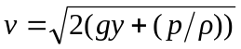
=
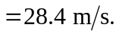

Note that y = 0 and 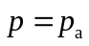 were used at the bottom of the tank, so that p was the given gauge pressure at the top of the tank.

